Dear new neighbor,
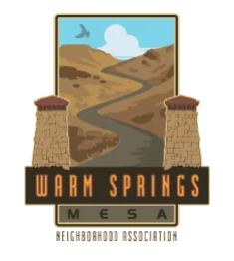
On behalf of the Warm Springs Mesa Neighborhood Association board, I’d like to welcome you and your family to the neighborhood. I’m glad to have you here and hope you’ll enjoy our neighborhood as much as I have.
The Mesa is truly a unique place that combines a close proximity to downtown, ample access to open space, and an amazing sense of unity within our neighborhood. You are one of about 700 homes that make up the neighborhood within our 540 acre footprint that extends to the Idaho Fish and Game Boise River wildlife management area to the north, Barber Valley neighborhood association to the east, the Boise River and Warm Springs Avenue to the south, and the Tram Trail of the Ridge to Rivers trail system to the west.
Check out our website at warmspringsmesa.org and take a moment to sign up for the email distribution list. This is the best way to stay informed on Mesa activities, community updates, and safety and road closure messages. Also, learn how our Neighborhood Association differs from the smaller Homeowners Associations in our boundaries, they are not the same. A Neighborhood Association is city sponsored and consists of a group of residents who come together to address community needs, advocate for neighborhood interests, and foster a sense of belonging.
I am excited to announce our 2026 community events are now available on the Mesa website. We encourage you to participate, meet your neighbors and enjoy all our neighborhood has to offer. These events are organized by Mesa volunteers and members of the neighborhood. Additionally, we invite you to contribute voluntary dues to WSMNA, which helps to support these events and ongoing neighborhood expenses.
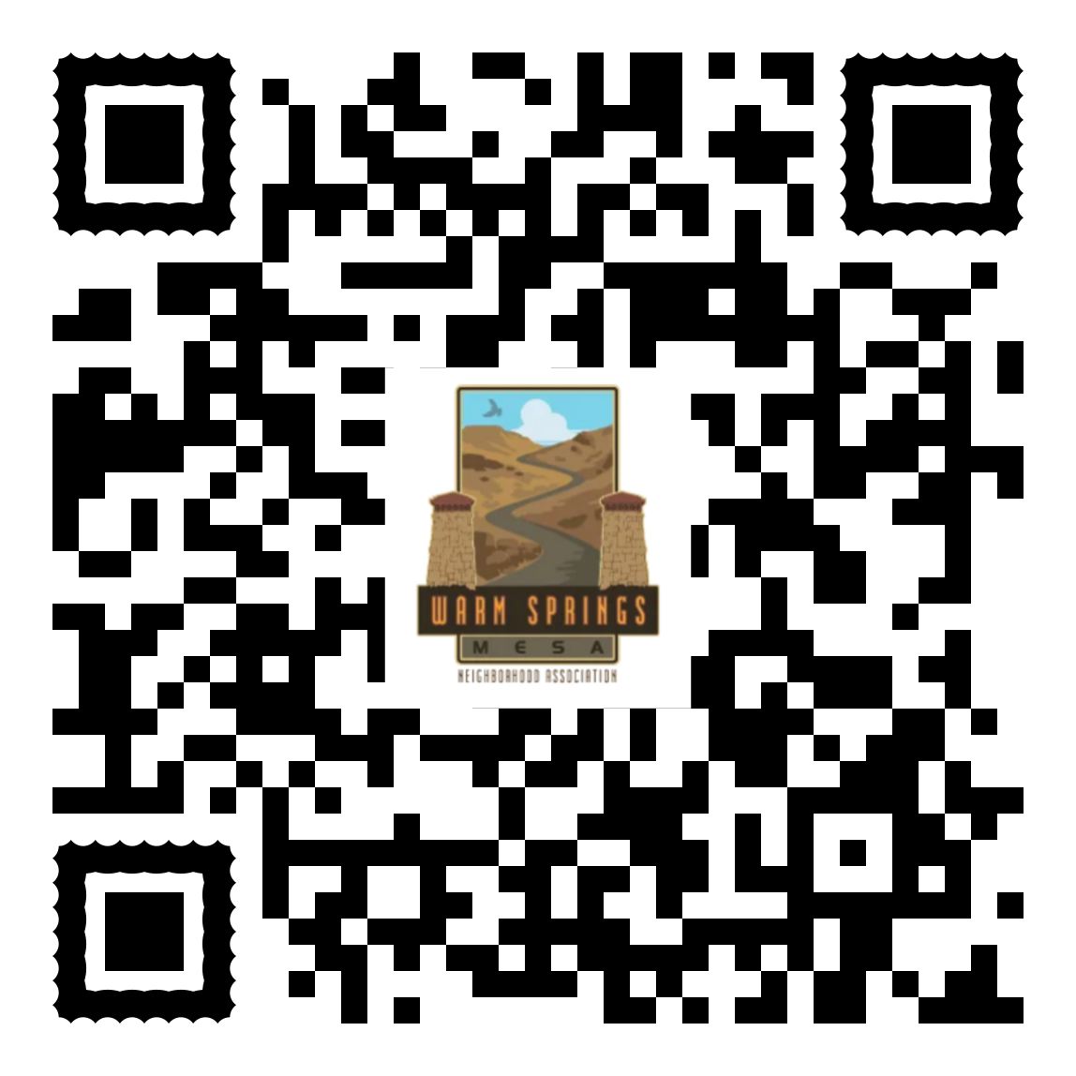
Get involved!
Volunteering at our neighborhood activities is also highly valued. This year, we will focus on programs that strengthen community bonds, including the Starcrest Drive garden initiative, Mesa trail enhancements, the ACHD Adopt-a-Highway program, several wildlife habitat restoration efforts, and our continued commitment to being a Firewise community and advancing preparedness through the M.E.S.A. program.
Welcome!
K.C. Shedden
WSMNA Board President & Mesa Firewise Coordinator

